Notes on using “BristolExample.vi”

The BristolExample.vi is intended to serve as an example of interfacing with LabVIEW directly to your Bristol Instruments wavelength meter without using the Windows dll that normally provides interfacing functions. Because the communications functions that are contained in the dll are replicated in the vi, the vi is considerably more complex than the simple “getWavelength.vi” that accesses the wavelength meter via the dll.

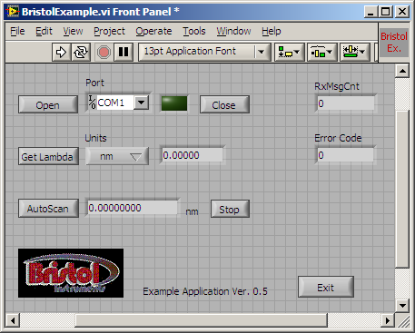

- To initiate communication with the wavelength meter, run the BristolExample.vi and then choose the appropriate com port on the Front Panel. This can be found in the pull-down list under the label “Port”. This is the same port that is indicated in the PC’s device manager when the instrument was initially installed. If you do not see the appropriate port, select “Refresh” at the bottom of the pull-down list. Also make sure that the instrument is powered on and that the USB cable is properly connected. Once the com port is selected, click on “Open”. When the port is opened, the indicator to the right of the port list will change color to a bright green.

- There are two modes of communication with the wavelength meter. The first one consists of sending a request to the instrument and then waiting for a reply. Clicking on the “Get Lambda” button accesses this mode. In this mode the units can be set using a pull-down menu and the instrument response will reflect that choice.

- Clicking on the “AutoScan” button accesses the second mode of communication. In this mode the instrument will automatically broadcast the measured wavelength at the end of each scan. This wavelength is always expressed in units of nanometers and is the vacuum value. To stop the broadcast of wavelength values, click on “Stop”.

- When you are finished with the vi, click on “Stop”, if AutoScan is enabled, and then click on “Exit”, which will halt operation and properly close the com port.

